Pack Tent Set-Up

Personnel Required: 4 Adults

Packaging

42 Poles
1 Large Green Bag
2 Smaller Black Bags
2 Loose Tarps (Light Gray)

Parts

Poles

Vertical Support (8): 68” long, Blue Arrow
Necked Roof Pole (17): 60” long, Red Stripe below narrow section
Straight Roof Pole (17): 60” long, Red Stripe near end
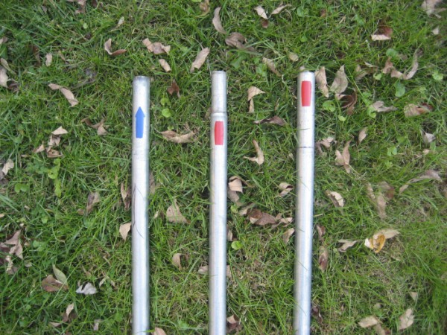
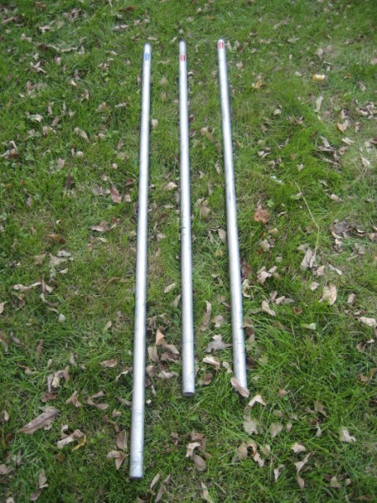

Pole Connectors

Middle Connectors (6)
End Connectors (6)
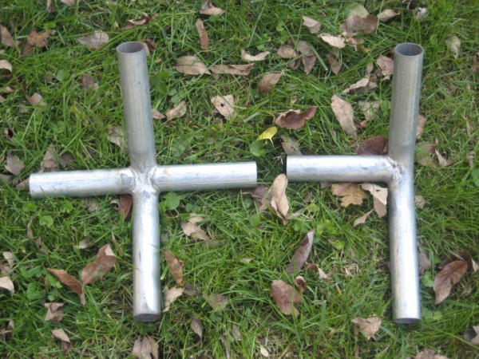

Tarps

Main Tarp (1): Approximately 30' x 20'
Side Tarps (2)

Tarp Fasteners (approximately 150)
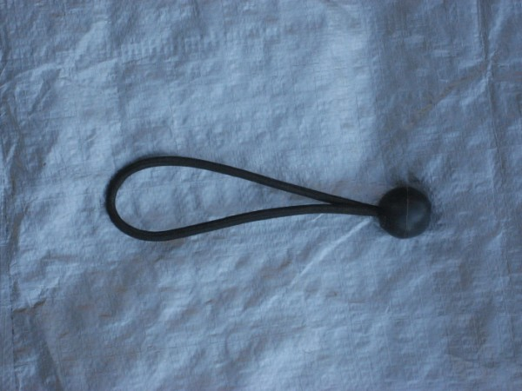

Miscellaneous
Small Sledge (1)
Rebar Stakes (8)
Aluminum Stakes (8)
Nylon Tie-downs with Clips (8)

Assembly

Assemble roof frame

Lay out pole connectors in their approximate positions.
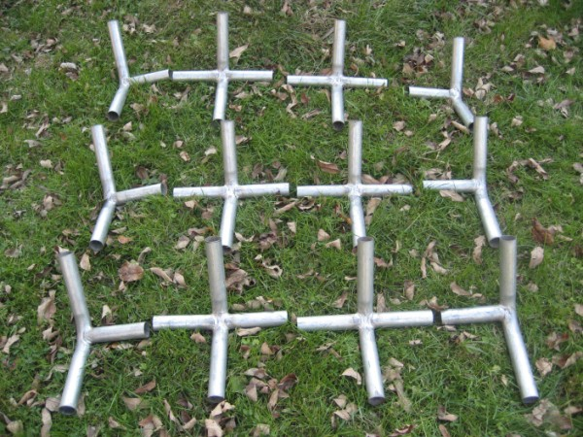
Join together necked and straight roof poles by aligning red stripes.
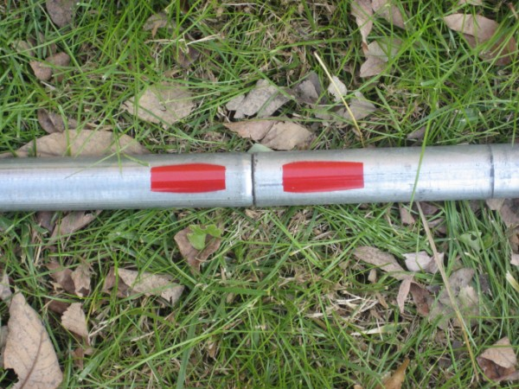
Insert joined roof poles into connectors to form roof frame.
(Tip: Tie rope to center of ridge-line to hang a lantern after assembly.)

Assemble Roof

Cover roof with Main Tarp.

Secure tarp with fasteners by pushing loop through grommet, going around the pole, and pushing plastic knob through loop.
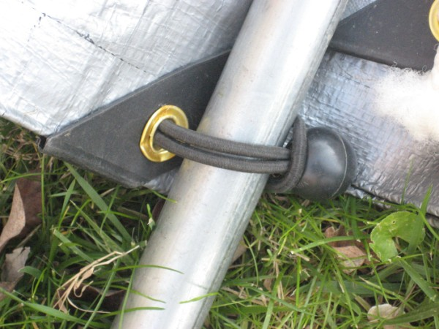
Tarp will be extremely tight.

Raise Roof

If 8 adults are available:

Have each take a vertical support pole (with Blue Arrow), and stand by a pole connector.

Simultaneously lift roof and insert vertical support pole in connector.

If 4 adults are available:

Have each take a vertical support pole (with Blue Arrow), and stand by a pole connector on the same side of the roof.

Simultaneously lift one side of roof and insert vertical support pole in connector.

Repeat previous two steps for other side.

Tie Down

Secure tent with eight tie downs at each vertical support pole if desired.
